Work-in-Progress/Informal Resource Guide for Bosque Access (Albuquerque area) for People Using Wheelchairs written for the Rio Grande Sierra Club and the Bosque Action Team May 2014
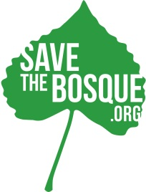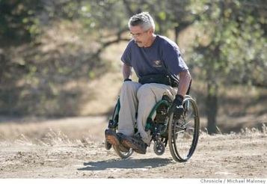
By Sarita Streng, Masters’ of Occupational Therapy Student at the University of New Mexico (UNM)
Background Information about author: I (Sarita) am a member of the Rio Grande Chapter of the Sierra Club (RGSC) and the Bosque Action Team (BAT). I am also an advocate for people who use wheelchairs and learning about occupational therapy, wheelchair use, accessibility, and more as part of the graduate program I am enrolled in at UNM.
Purpose of this document: I am putting this information together so that people in both the RGSC and BAT may have a beginning resource guide to help members of these groups and other people in wheelchairs who are interested in visiting the Bosque some ideas about how to do this. Access to the Bosque for people using wheelchairs needs to be improved and I have made a few recommendations about his. Additionally, since both the RGSC and BAT are interested in keeping the Bosque as a primarily wild space and supporting wild-life habitat, I have included some resources and ideas about ways that “access” for people using wheelchairs can better co-exist with nature. This is a work in progress and I would love input. More research and work need to be done for a more complete picture. I can be contacted at saritastreng@yahoo.com or 505-288-8713.
Table of Contents:
- Overall map of the area and Rio Grande Valley State Park
- Legal Matters: ADA and More
- What are some “accessible areas” of the Bosque for people using wheelchairs?
- What is the best trail surface for a person using a wheelchair?
- A variety of wheelchairs
- Outings to the Bosque for People in Wheelchairs
- What are other wilderness groups doing to support access for people in wheelchairs?
- Additional Perspectives including people-first language
- Appendix with other Resources and Articles of Interest

- Overall Map of the Area and Rio Grande Valley State Park
The majority of the Bosque in the Albuquerque area is within the Rio Grande Valley State Park. The park includes approximately 4300 acres and spans from Sandia Pueblo on the north end to Isleta Pueblo on the south end. The park is managed by Albuquerque’s Open Space Division, State Parks, the US Fish and Wildlife Service, the Army Corps of Engineers, and the Middle Rio Grande Conservancy District. A great deal of information about the park and general access points can be found at the following link: http://www.cabq.gov/parksandrecreation/open-space/lands/rio-grande-valley-state-park. Maps with information about where Americans with Disabilities (ADA) parking, picnic tables, and short “accessible” trails are located are included in this website. This is a very important document to share with anyone in a wheelchair who is asking for information about “wheeled access” to the Bosque.
- Legal Matters
Keep in mind include that if you see a sign in nature that says “no motorized vehicles” motorized wheelchairs are an exception. However, if a person has a disability, that does not entitle them to take all kinds of mechanized vehicles into a natural area. The laws regarding “other power driven mobility devices” (OPDMDs) are complex.
States use federal mandates as ideal guidelines for park design but presently state sites follow (or are supposed to follow) Americans with Disabilities Act (ADA) guidelines. The RGVSP is under state management. Currently the Federal Access board is in the process of matching the September 2013 federal guidelines to the ADA laws. Any future development of the Bosque/RGVSP would need to comply with current ADA requirements.
If the Bosque were ever to come under federal management, trail management and design would need to follow guidelines of the Architectural Barriers Act (ABA) of 1968 which requires accessibility in all government owned and leased facilities. In September 2013, the U.S. Access Board issued new accessibility guidelines for outdoor areas that are on federal land. These guidelines include detailed specifications about accessible trails, picnic areas, viewing areas, and other components of development for primarily outdoor areas. These guidelines also provide guidelines for when terrain or other factors make non-compliance acceptable. Some factors that may also affect compliance include conflicts with the Endangered Species Act or when compliance may alter a site’s “function or purpose.”
- What are some “accessible areas” of the Bosque for people in wheelchairs?
There is not a clear-cut answer for this question. In addition to trail surface, other factors to consider include what kind of wheelchair a person has, his or her fitness level, and whether or not the person wants to go into the Bosque by himself/herself. Some of the “lay of the land” and access points can be located at the map listed earlier in this document: http://www.cabq.gov/parksandrecreation/open-space/lands/rio-grande-valley-state-park
I went on some “scouting” trips to investigate access points with accessibility for people in wheelchairs in mind. Below are some notes and comments from my observations that I am preparing for the RGSC and BAT websites:
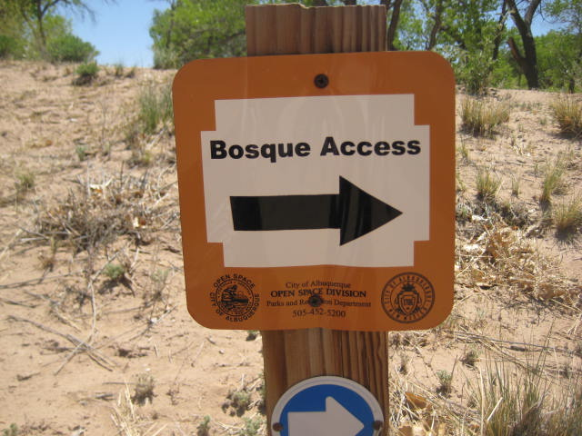
Basics: The City has a very helpful map on its website to find general access areas for the Rio Grande Valley State Park which most of the Albuquerque Bosque is located in. Use the following link to access this information: http://www.cabq.gov/parksandrecreation/open-space/lands/rio-grande-valley-state-park
I (Sarita Streng) went to most of the sites listed on the City website.
Here are my additional observations and recommendations for people using wheelchairs who want to visit the Bosque:
Basics: The City of Albuquerque has a very helpful map on its website to find general access areas for the Rio Grande Valley State Park which most of the Albuquerque Bosque is located in. Use the following link to access this information: http://www.cabq.gov/parksandrecreation/open-space/lands/rio-grande-valley-state-park
I (Sarita Streng) went to most of the sites listed on the City website.
Here are my additional observations and recommendations for people using wheelchairs who want to visit the Bosque:
Access Point: Bachechi Open Space – formerly the Bachechi Family farm 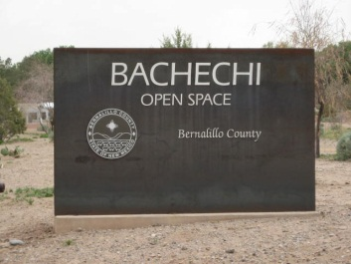
This area has a wetlands area, small forested area, educational center, and a rose garden. This area is outside of the levees of the river. The wetlands, educational center, and garden seem accessible in most wheelchairs. There is ADA parking and an ADA bathroom. The small forest has a surface that may be more difficult or impossible to access – soft “shredded wood” is the surface. The forest has been cultivated to attract wild birds and show off native trees and plants.
Here is an example of parking:
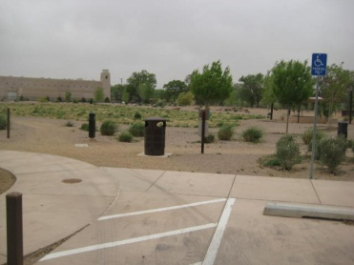
Here is are some photos of the ground surface covering the majority of the open space area – mostly hard packed dirt with a bit of crusher fine:
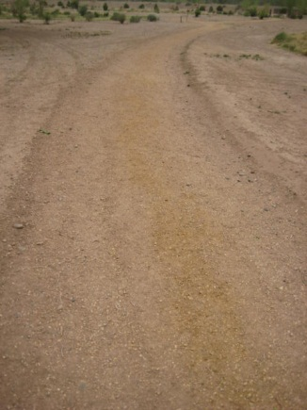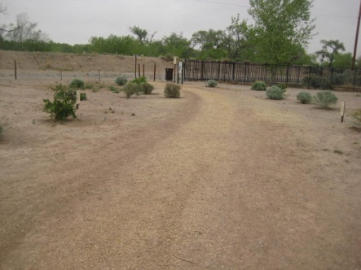
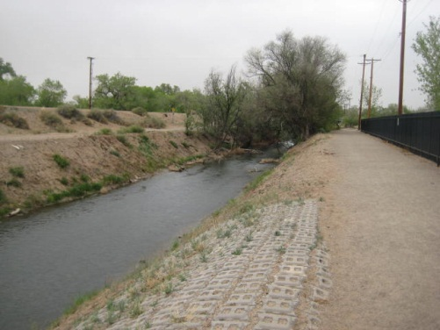
Bird-viewing blinds for the wetlands – fairly hard-packed surface:
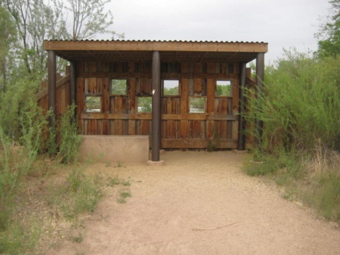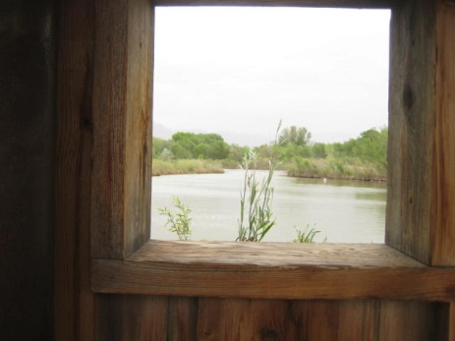
Sign from the forest trail and photo of the ground cover:
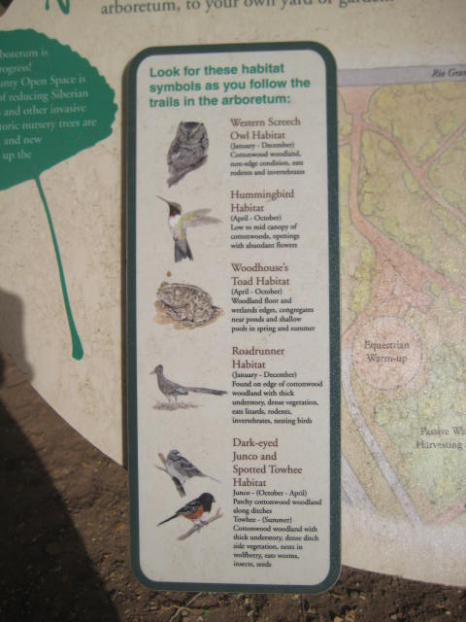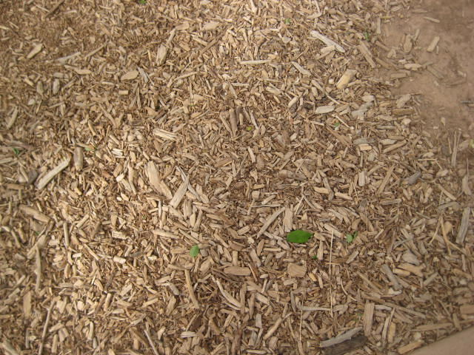
A traditional acequia can be viewed from a hard-packed dirt path:
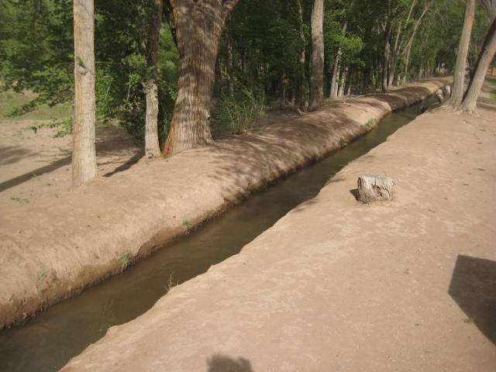
A photo of the educational building which has ADA bathrooms and offers many classes to the community free of charge or at a very low cost to learn about local nature:
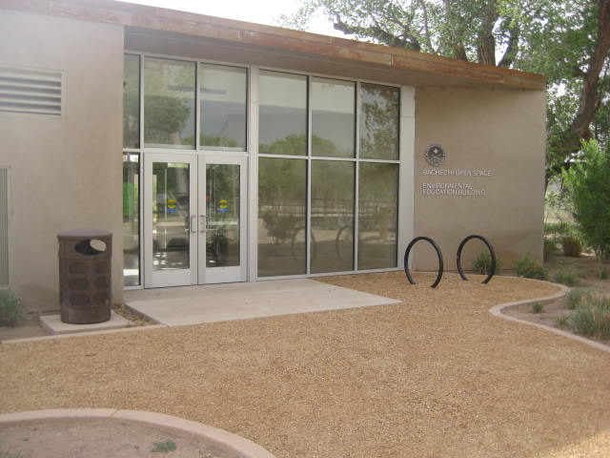
The Paseo del Bosque Trail (all concrete) can be accessed from the north side of Bachechi Open Space. See more information about the Paseo del Bosque trail later in this document.
Recommendations for this area: try it out in a wheelchair, ask Open Space to consider different ground surface for the forest area that would be more accessible
Access Point: Open Space Visitor Center (“West Side”)
This area and land also used to be a family farm and includes 18 acres of agricultural lands/fields. There are ADA accessible bathrooms. The area – outside the levees – includes indoor and outdoor exhibits about local wildlife, land formations, and farming history. On the outside of the building there are gardens that replicate ancient Pueblo-style gardening and an ADA accessible deck that overlooks agricultural fields. The roads around the agricultural fields are hard-packed dirt with some loose gravel. This is a spectacular place to watch migratory birds including sand hill cranes. Inside the building are interpretive exhibits about the natural history and cultural history of the area. Going closer to the river from this Center in a wheelchair looks nearly impossible. I walked it on foot and there were many barriers. Also, some ADA features in and around the center are missing. I spoke with the staff about this and they said that the City had been at the Center recently and is planning on improving ADA access to the building (which is a historic farm house) in the near future.
The access point to get to the river from the Open Space Visitor Center can be accessed by walking (no access in a wheelchair) from the Center or from a nearby parking lot behind Sage Brush Church – a person using a wheelchair could travel in a motor vehicle to this parking lot. Going to the river and the trails that get to it seem extremely difficult/impossible in this area for a person using a wheelchair because a significant portion of this trail is deep sand and in order to get to the trails a person also has to get over an area with significant slopes. The only way I could see a person using a wheelchair accessing this area is if they had a wheelchair built for deep sand and/or people to help push/carry him/her part of the way – therefore, an inaccessible area for vast majority.
Here are some photos in and around the Open Space Area:
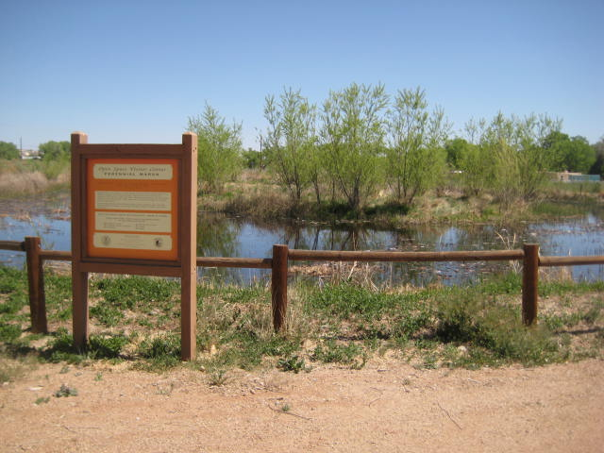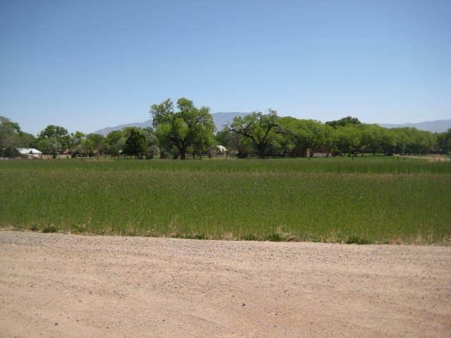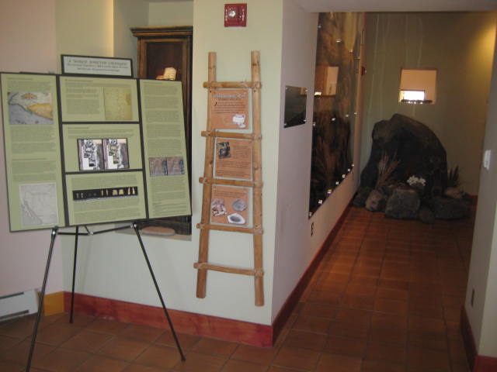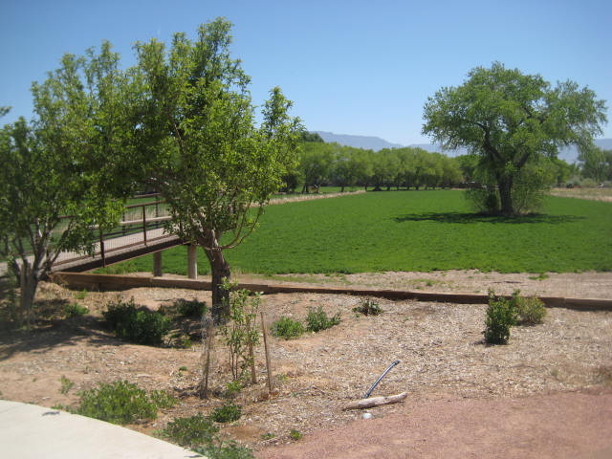
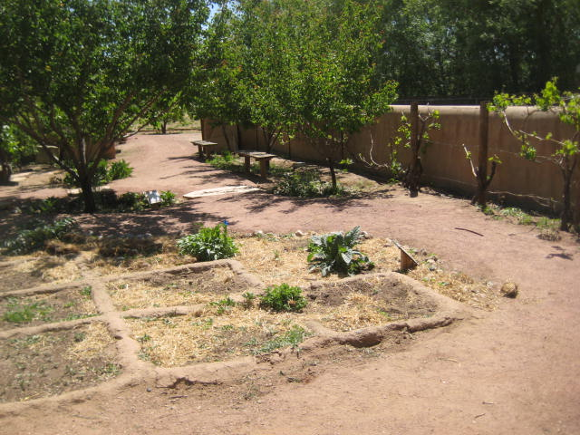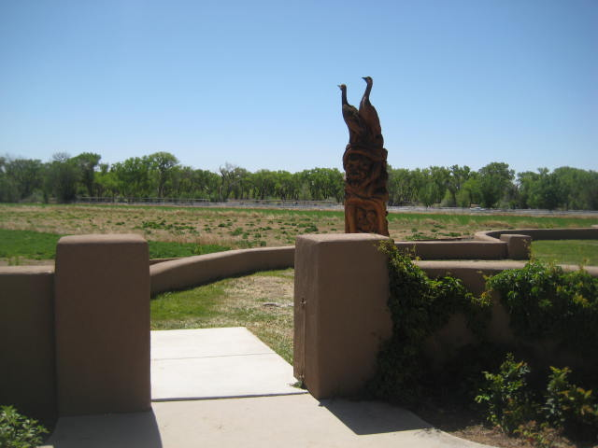
Here are the photos of the area near Open Space that leads to river trails that seems impossible to access in most wheelchairs:
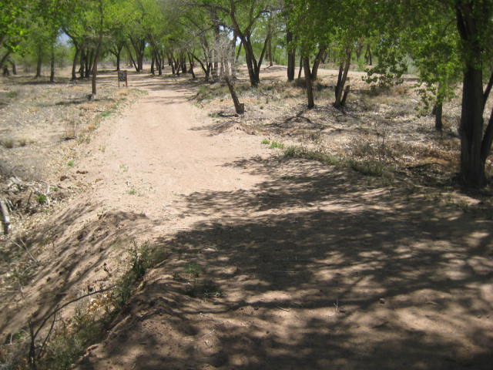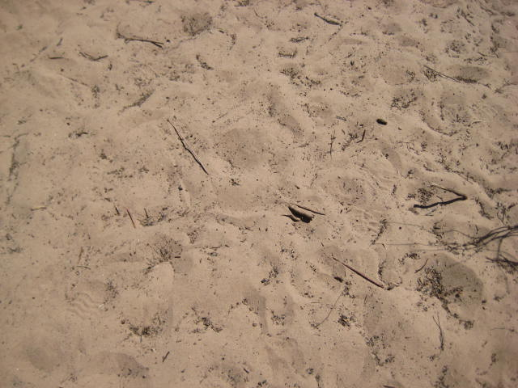

Access Point: Pueblo Montano (need tilty on n in Montano) Picnic Area and Trailhead
This area includes an ADA accessible picnic ground outside the levee with a small concrete trail loop. The area was heavily affected by fire in 2003. What was left of burned cottonwood trees was turned into a sculpture collection (built from partially burned trees) by retired firefighter and chainsaw artist Mark Chavez.
The trailhead to get past the levees to get under the Bosque canopy or closer to the river looks like it would very difficult/impossible to navigate for most people who are in wheelchairs as it has a high slope and very uneven terrain.
One female naturalist in the Albuquerque area who uses a wheelchair said that she would not go here by herself in a wheelchair as she felt unsafe in terms of crime although I have no official statistics about the area.
Here is a photo of one of the sculptures and other images from this accessible picnic area:
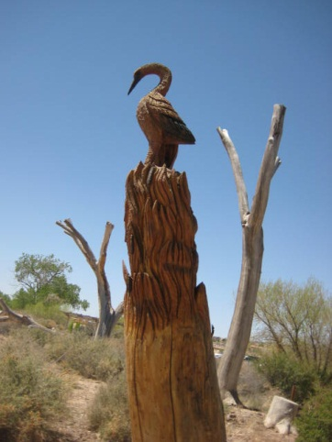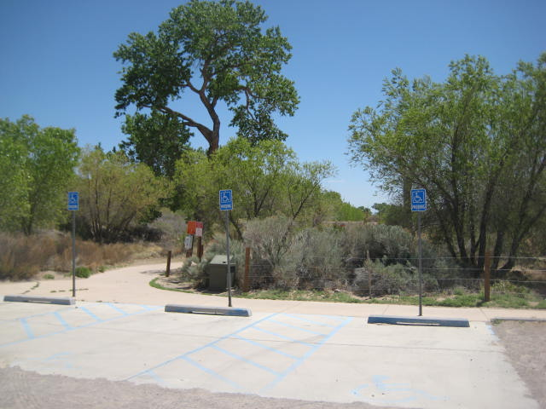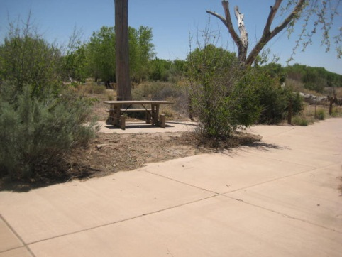
Access Point: Rio Grande Nature Center
Note: Parking here costs $3 or an annual parking permit may be purchased
This Nature Center includes a building with a viewing room of wetlands, an interpretive exhibit about Bosque wildlife, native plant gardens, wetlands, two trails, a wildlife rescue center, an additional educational building, and access to the Paseo del Bosque trail. This Center has ADA accessible parking and bathrooms. The Center offers many free or low-cost classes to learn about the Bosque, its plants, and wildlife. There is also an additional wetlands area here – the “Candelaria Wetlands” that has ADA parking and a very short concrete path to access the viewing blinds for the wetlands. The Candelaria wetlands area is easily accessible in a wheelchair for a person who would like to see migratory and wetland birds.
I think (and again this is a preliminary document) that this access point is the best for people using wheelchairs who want to go into areas of the Bosque that are inside the levee, get close to the river, and be under the forest canopy. The main challenge for a person in a wheelchair in order to get to the nature trails include going up/down a somewhat steep slope after crossing the irrigation ditch.
Here is a photo of the slope that a person would need to get up/down – see slope to right after crossing bridge:
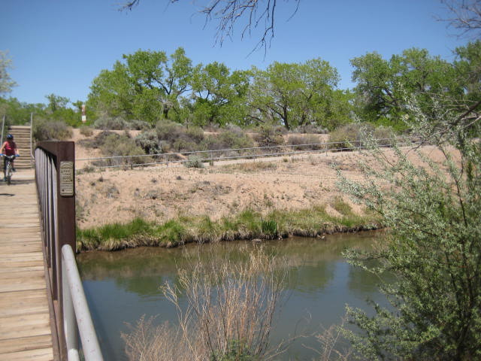
Beyond this slope, a person would have access to two different trails: 1) a circular river trail and 2) the Aldo Leopold Trail.
The circular river trail is predominantly hard-packed dirt with some areas that are sandier – very light sand the two days I visited. The ground surface could change depending on weather and wind. I think that this trail is fairly accessible for a person in a wheelchair who is comfortable on hard-packed dirt unless there has been recent heavy rainfall. The complication here is that only the south half of the trail is accessible to a person in a wheelchair because the north half of the trail includes stairs. There is also more sand on the north side of the trail. My recommendation would be that a person using a wheelchair go to the river on the south half of the trail and then return the same way – as opposed to making a loop. Porcupines high up in trees are frequently seen from this trail.
The other trail – the Aldo Leopold trail is fully paved and 1.25 miles long. This is a great way to get under the Bosque canopy for a person who wants/needs a paved trail.
Here are some views of the Aldo Leopold trail – one photo is looking up at the canopy of the Bosque:
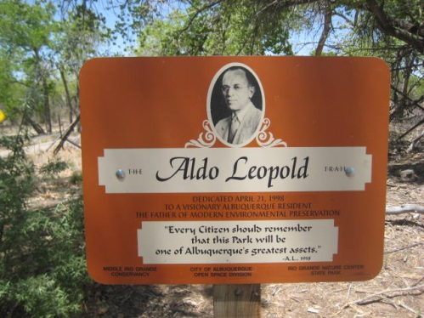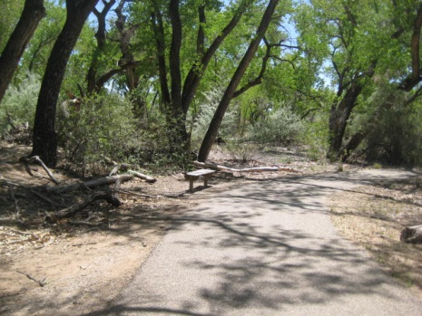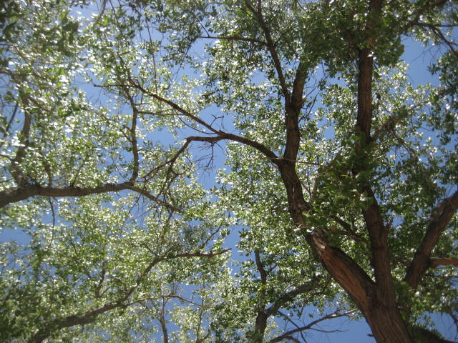
I spoke with the superintendent of the Rio Grande Nature Center Beth Dillingham about this project. She wanted to help me and really seemed to want to help people in wheelchairs access the Bosque. She said, “People with wheel chairs do use the Aldo Leopold trail that is paved. They go across the bridge and up the paved ramp not the stairs. The gradient likely does not meet the ADA code. I have never measured. ADA accessibility is not great anywhere that I am aware of in the Bosque. Although we have a huge number of people with disabilities come here.”
I was disappointed that the Aldo Leopold Trail does not go all the way to the river – it goes almost to the river and then a person would have to navigate deep sand to get to see the river.
Recommendation: I recommend that the Aldo Leopold trail be extended so that people using wheelchairs can more easily access a river view. I also recommend that the area between the nature center and the trail – the area over the levee – be made ADA accessible.
Access point: Tingley Beach
Most of this area which is as sort of “fishing park” with constructed fishing ponds and is east of the Paseo del Bosque trail. The trail around the ponds is cement and there are ADA bathrooms. Many families and people like to spend time at these ponds watching ducks, fishing, playing with model boats, and just being outside.
Near Tingley Beach – from a parking lot on the northeast corner of Central and the River – a person can access the Paseo del Bosque trail. Also, near the southeast corner of this intersection there is a boardwalk out to the river that is ADA accessible. There are a variety of paths in this area that go along the river with a variety of ground surfaces. There is currently a service road that is hard packed dirt with some loose gravel in this area but I am not sure how long this service road will be maintained.
Access Point: Valle del Bosque Community Access
This area has a picnic area that is ADA accessible and a very small loop around the picnic area (1/4 miles) outside the levees. Getting past the levees includes going through a trail gate that is impossible a person using wheelchairs. From there, a person needs to go up/down a dirt path that has a pretty steep slope. Once the person has done that, there is an ADA accessible boardwalk on the other side.
Here is a photo of the trail at the picnic grounds outside the levee:
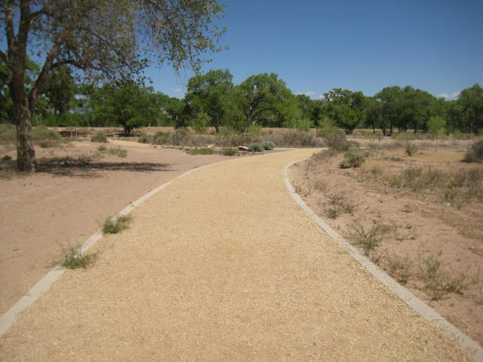
Here is a photo of the trail gate a person would need to be able to pass through:
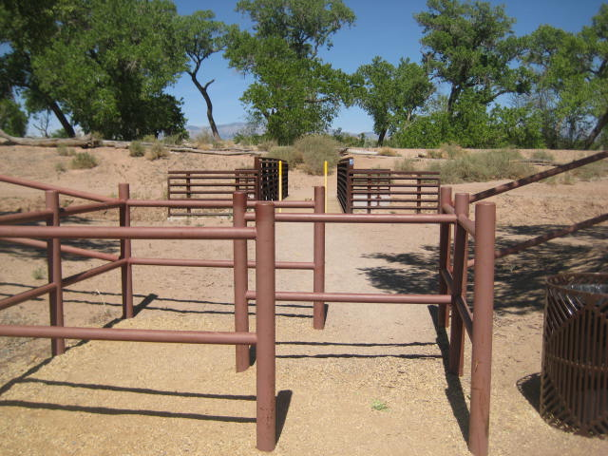
Here is a photo of part of the path leading to the river – lots of loose gravel and steeper than it appears in this photo:
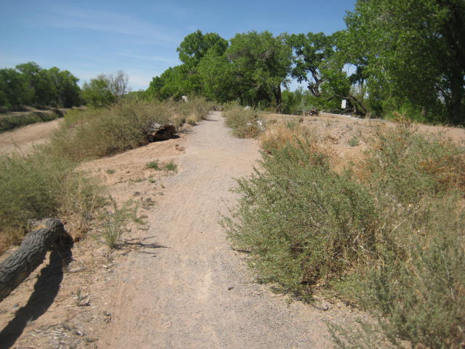
ADA accessible Boardwalk that leads to river:
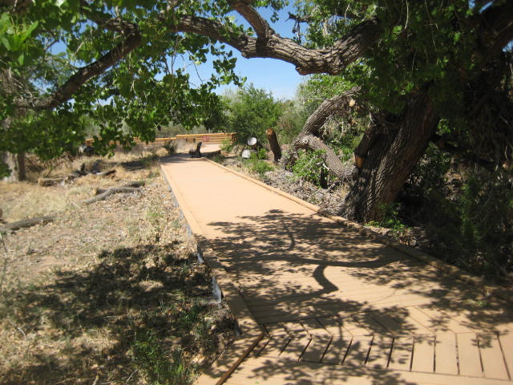
Recommendations for this site: This site is very confusing because there is an area near the river that is very accessible but getting to it is nearly impossible. I recommend that this area is re-designed.

Access Point: Rio Bravo Riverside Picnic Area, Fishing Pier, and Nature Trail
This area includes a small (approximately 1/4 mile) trail made of crushed gravel, ADA parking, an ADA fishing pier for the irrigation ditch, and a picnic area. There are also some hard-packed dirt trails beginning in this area which seem like they could be navigated by a person who was comfortable with a hard-packed dirt trail with some tree roots.
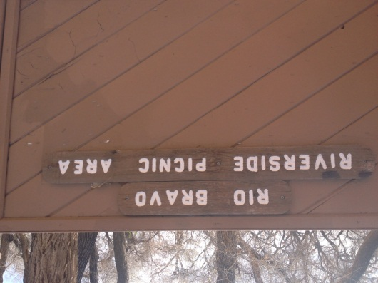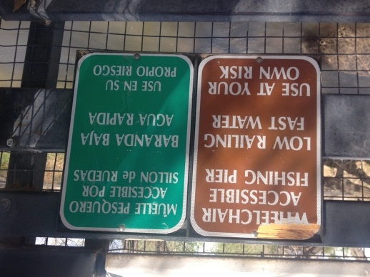
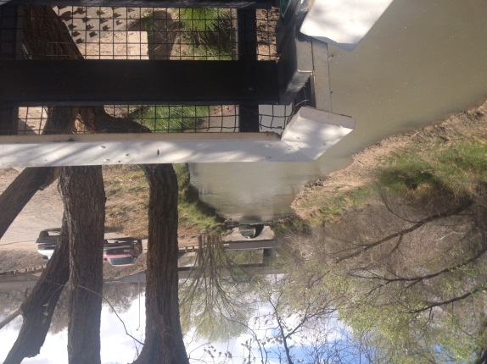
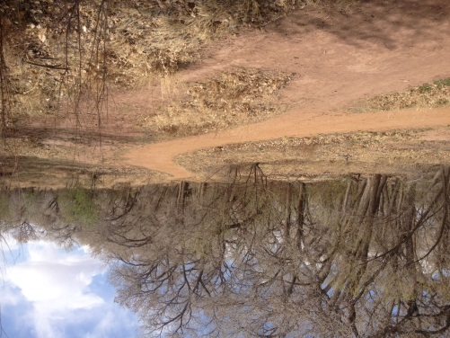

Paseo del Bosque Trail:
This is a 16 mile paved trail that is located on the east side of the river – outside of the levees. Some of the access points for this trail have been mentioned in the access points above. Many people in Albuquerque know this trail as the “bike trail” but the trail is also used by skaters, runners, people using wheelchairs, and people with strollers. This path is free of motor vehicle traffic. When the trail comes to streets with cars, there are bridges one can go under and sometimes there cross walks. The most challenging parts of this trail for someone using a wheelchair may include – no bathrooms on this trail, some of the places where people have to go under a street – such as Montano (tilty on n in Montano) the slope may be way too steep, and there can be heavy bicycle traffic. Wheelchairtravelling.com recommends this trail. There are no bathrooms along this trail.
I would recommend that this trail creates safer access for people using wheelchairs at the street crossings.
Other options: There are ways to visit the Bosque in a non-motorized boat. For more information see http://www.cabq.gov/parksandrecreation/open-space/lands/enjoying-the-rio-grande

D.What is the best trail surface for a person using a wheelchair?
Again, there is not an easy answer to this question. There are many options. I think that the article below by Janet Zeller who is USDA Forest Service Accessibility Program Manager can answer this question better than I can at this time. Her article addresses solutions for federal compliance for trail standards and I believe it can be a guide for the Sierra Club and BAT.
Surfaces for accessible trails
Construction tips and definitions of accessible surfaces for trails from the USFS Accessibility Guidebook on Outdoor Recreation and Trails.
From the New Years 2007 American Trails Magazine
The surface of an Outdoor Recreation Accessibility Route and the surface surrounding constructed features must be firm and stable. No exceptions are allowed. Slip resistance is not required because leaves and needles, dirt, ice, snow, and other surface debris and weather conditions are components of the natural environment that would be difficult, if not impossible, to avoid.
Paving the Wilderness?
Does a firm and stable surface always mean concrete and asphalt? No; however, the surface provision states that the type of surface material used should be appropriate to the setting and level of development. Some natural soils can be compacted so they are firm and stable. Other soils can be treated with stabilizers without drastically changing their appearance.
Many surfaces that appear natural and that meet the firm and stable requirements also are available on the market. Designers are encouraged to investigate these options and use surfacing materials that are consistent with the site's level of development and that require as little maintenance as possible. Asphalt can be a good option.
What is Firm and Stable?
What sort of surface is firm and stable? In general, if the answer to both of the following questions is yes, the surface is probably firm and stable:
- Could a person ride a narrow-tired bicycle across the surface easily without making ruts?
- Could a folding stroller with small, narrow plastic wheels containing a three-year-old be pushed easily across the surface without making ruts?
Firm and stable surfaces prevent assistive devices from sinking into the surface, which would make movement difficult for a person using crutches, a cane, a wheelchair, or other assistive device. In the accessibility guidelines, the standard assistive device is the wheelchair because its dimensions, multiple moving surface contact points, and four wheels often are difficult to accommodate. If a person using a wheelchair can use an area, most other people also can use that area.
Construction Tips on Surfacing Materials
Generally, the following materials provide firmer surfaces that are more stable:
- Crushed rock (rather than uncrushed gravel)
- Rock with broken faces (rather than rounded rocks)
- A rock mixture containing a full spectrum of sieve sizes (rather than a single size)
- Hard rock (rather than soft rock that breaks down easily)
- Rock that passes through a 1Ú2-inch (13-millimeter) screen
- Rock material that has been compacted into 3- to 4-inch (75- to 100-millimeter) thick layers (not thicker layers)
- Material that is moist, but not too wet, before it is compacted (rather than material that is compacted when it is dry)
- Material that is compacted with a vibrating plate compactor, roller, or by hand tamping (rather than material that is laid loose and compacted by use)
The Forest Service Accessibility Guidebook on Outdoor Recreation and Trails will help users integrate accessibility into planning, design, construction, and maintenance of outdoor recreation facilities and trails while maintaining the natural setting. It provides detailed information about accessibility requirements in an easy-to-use format, with photos, illustrations, and design tips, hotlinks, and sidebars. This guidebook will also help Forest Service personnel, partners, contractors, and Federal and State agencies working in cooperation with the Forest Service understand how to apply the Forest Service Outdoor Recreation Accessibility Guidelines and Forest Service Trail Accessibility Guidelines.
Tony Anella also suggested considering “permeable paving.”
- A Variety of Wheelchairs
There are many kinds of wheelchairs and some are more or less suited to nature activities.
Some wheelchairs include manual wheelchairs, power wheelchairs (electric-powered), manual chairs that are built for outdoor activities – some which are considered “all terrain.” “All terrain” wheelchairs can be expensive.
Here are some examples of wheelchairs:
Manual wheelchair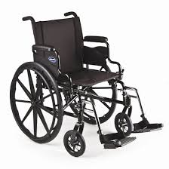

Beach wheelchair from the Netherlands – these are available at public beaches for loan or rent:
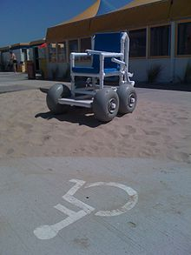

Leveraged and relatively low-cost wheelchair in Kenya designed for un-even ground
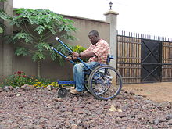

All-Terrain Wheelchair 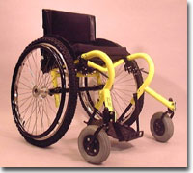

Power (motorized) wheelchair 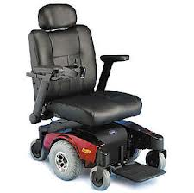
Many wheelchair users in Albuquerque own one wheelchair – wheelchairs can be expensive!
Some nature programs in other parts of the country and in other countries have “loaner” and rental chairs for wilderness and nature excursions.
Recommendation: Suggest to the Rio Grande State Park that they provide wheelchairs that are suitable for nature expeditions for low rental price or as loaners
- Outings to the Bosque for People in Wheelchairs
I investigated the availability of organized outings to the Bosque available for people in wheelchairs. I did not find any. I did find one person in the Sierra Club who is interested in creating such an outing. His name is Colston Chandler. He has been researching organizing an outing to the Bosque for people in wheelchairs with the organization OASIS. The Sierra Club would love to have a volunteer organize this outing.
What are other wilderness groups doing to support nature access for people in wheelchairs?
There are so many examples of ways to support nature access for people in wheelchairs that I cannot write about them all here. Of course, advocating that State Parks follow ADA laws is key.
I will give some other examples:
  - The Sierra Club in the San Francisco Area has had “SOAR” groups and outings in the past:
“Sierrans Outdoors through Accessible Recreation (SOAR) creates opportunities for people of all abilities to participate in and lead Sierra Club activities. Our hikes are non-competitive and open to anyone with a sense of adventure. Children and families, seniors, new hikers, and people with physical, cognitive, and sensory impairments are all welcome. Some participants are long-time hikers who are recovering from injury, or just want to see things at a different pace. Other participants have permanent disabilities that require scouting hikes with accessibility issues in mind. Most SOAR trips are also accessible by public transit. We often invite naturalists or other interpreters to join our hikes and help us distinguish and enjoy the plants, animals, and natural processes we can observe on even a short journey. Hiking at a slower pace gives us the opportunity to pay closer attention” (From Sierra Club San Francisco Bay Chapter)
A group called “Wilderness Inquiry” organizes trips that include people of all abilities. Here is some information from their website:
- Wilderness Inquiry is all about access, inclusion, and opportunity. We believe exploration of the natural world is a birthright we all share, and we act on that belief. We operate in a manner that facilitates full participation by everyone, including people who come from different physical, cultural, or socio-economic places. We believe in the power of community.
- Share the Adventure is more than just a slogan for us. We welcome everyone to participate. In addition to the many adventures featured on this site, as a non-profit organization we also conduct programs that introduce people of all ages, backgrounds and abilities to the outdoors in positive, life-changing ways.
- Our programs provide opportunities for urban youth, families, and people with disabilities to discover and share the many benefits of outdoor experiences. Our founders realized long ago that the true beauty of the outdoors is that it helps us all discover our common humanity.
- Due to the conditions in which we travel, manual chairs work best. Knobby tires are very helpful, as are balloon front tires. Most modern wheelchairs are adequate. We sometimes use adaptive equipment to facilitate the journey, like our fabulous “rick-shaw” device that turns a standard wheelchair into a trail machine in moments.
- Thousands of people with a wide variety of disabling conditions have traveled with Wilderness Inquiry. Over the years we’ve come to realize that “disability” is a very relative term– what’s really important is each individual’s attitude and their willingness to get out and do things. The rest is mostly details. We do have some great adaptive gear that we’ve found or developed along the way, such as seating or mobility aids like the “rick-shaw.” Our staff are always there to help provide a boost or a lift if needed, and we regularly accommodate trip assistants, personal care attendants, and sign language interpreters when needed
- Our trips are integrated, meaning that each group is made up of people who do not have disabilities traveling with others who do. What brings them together is their interest in doing a wilderness adventure. We do whatever it takes to make our trips accessible, but disability is not the overt focus. We just want to get out there and enjoy the wilderness together. We provide adapted equipment as needed, including canoe and kayak seating, mobility aids, accessible bathroom facilities and many other things. This gear really helps people participate as equals, but it is not what makes Wilderness Inquiry so accessible. The most important element is that we treat people as equals. We work with everyone to help figure out what we need to do to maximize full participation in a straightforward, non-condescending manner. In short, we just do it.
- 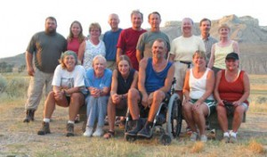
- Wilderness Inquiry uses a “rickshaw” mobility aid to help some of the participants in
- wheelchairs 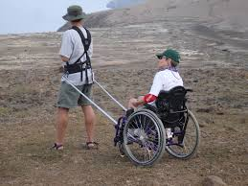

- Additional Perspectives including people-first language
  - For my friends at the SC and BAT, many people in the community who use wheelchairs or who have other disabilities prefer “people first” language. What does that mean? Basically, a person who has a disability such as paraplegia or Parkinson’s may be prefer to be referred to as “as person with paraplegia” as opposed to “a paraplegic” or a “paraplegic person.” For more information, see http://www.disabilityisnatural.com/explore/people-first-language.
  - A survey and documentation process that accompanies the planned outing to the Bosque that would record people’s difficulties and suggestions is planned to help inform future policy decisions when the SC and BAT are advocating for policy regarding the Bosque. Questions such as: What types of environmental supports would you like to see (if any) for people in wheelchairs to be able to access the Bosque? What do you think the best trail surfaces are for wheelchair users in Bosque? need to be addressed.
  - City Councilor Ike Benton who is an architect and friend of BAT may have thoughts to share about this topic

Thank yous
- to Beth Dillingham, superintendent of the Rio Grande Nature Center, for sharing information with me
- to Anthony Anella of the Aldo Leopold Foundation and BAT for sharing his ADA knowledge and reference book with me
- to Camilla Feibleman, Director of the Rio Grande Sierra Club, for her enthusiasm and support of this project
- to Terri O’Hare for her input and suggestions
- to Dr. Terry Crowe and Dr. Betsy VanLeit (Occupational Therapy professors at the University of New Mexico) for helping me learn so much about occupational therapy and community health
- to my husband Nick Babic and my daughter Amelia Babic for their support with all my school projects and for loving the Bosque, too
- to the Bosque, the place, the animals

- Appendix – Other Resources and Articles that May Be of Interest

Here is an Accessibility Guide I Received from Beth Dillingham, Superintendent of Rio Grande Nature Center:
Accessibility Guidelines Quick Guide: Which Accessibility Guidelines Apply Where
ADA/ABA Accessibility Guidelines  (ABAAS =  ABA Chapters 1 & 2  and 3 through10) | Apply only within National Forest System boundaries
 | FSORAG | FSTAG
Buildings,  Boating & Fishing | Developed Recreation Site Constructed Features | Hiker/Pedestrian Trails that meet ALL of the following criteria
all buildings, including:  - administrative offices  - residences  - crew quarters  - visitor centers  - entrance stations  - parking lots  and including components such as:  - restrooms with and  without running  water  - drinking fountains  - work stations  - doors  - operating controls  (door handles, faucet  controls, etc.)  - crew quarters/  residences  Boating and  Fishing Piers & Docks | newly constructed or reconstructed:  - picnic areas - picnic tables  - fire rings - cooking surfaces  - grills - pedestal grills  - woodstoves - fireplaces  - benches - beach access  - outdoor recreation access routes  - campsites (tables/cooking pads,  parking spurs, tent pads, platforms)  - campground utility connections  - water hydrants  - outdoor rinsing showers  - remote area pit toilets  - trash/recycling containers  - viewing areas and overlooks  - telescopes and periscopes  - mobility device storage  - warming huts | 1. new or altered trails  and  2. designed for hiker/  pedestrian use  and  3. trail connects  directly to a trailhead or  - connects directly to  a currently accessible trail.

Links to other articles that may be of interest:
Wheelchairs and wilderness can coexist by Erik Schultz http://www.csmonitor.com/2005/1003/p09s01-coop.html
Wheelchairs in the wilderness by Erik Schultz http://www.hcn.org/issues/312/15986\
Wheel to Sea by Brad Childs http://wildernessinstitute.com/call/personal-growth/wheels-to-the-sea/

Seeing wilderness from a wheelchair is disabled people's right by Judi Severson http://rapidcityjournal.com/news/opinion/seeing-wilderness-from-a-wheelchair-is-disabled-people-s-right/article_d6bca7eb-69ff-5be0-86cd-7706de2fc0f0.html
http://webhost.bridgew.edu/jhuber/readings/trailblazing_in_a_wheelchair.html
http://www.academia.edu/5203701/_Risking_the_Body_in_the_Wild_The_Corporeal_Unconscious_of_American_Adventure_Culture_Journal_of_Sport_and_Social_Issues
http://www.hcn.org/issues/312/15986
http://www.mtexpress.com/index2.php?ID=2005104207&var_Year=2005&var_Month=07&var_Day=20#.U18lhlcumSo

Top of Form
Bottom of Form

